Chapter 10, Problem 86.

Use PSpice to find V₁, V₂, and V₃ in the network of Fig. 10.128.
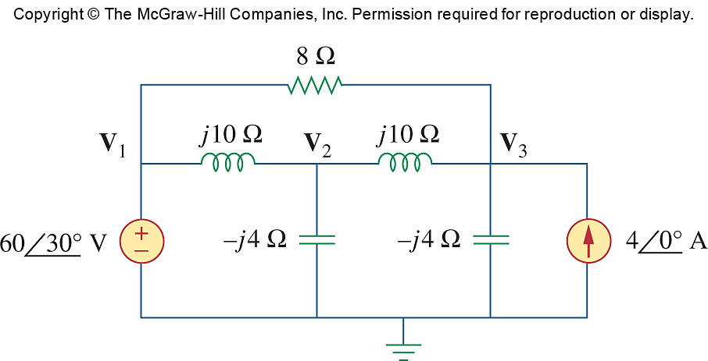

Figure 10.128
For Prob. 10.86.

